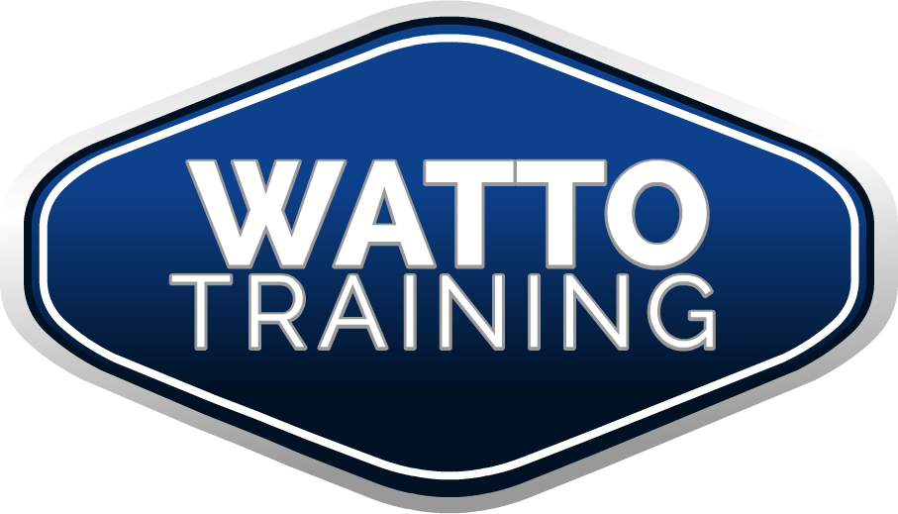

Dear Applicant,

This document summarizes requirements for the RPL / Credit Transfer process for the following qualifications:
- TLI41210 Certificate IV in Transport and Logistics (Road Transport - Car Driving Instruction)
- TLI41310 Certificate IV in Transport and Logistics (Road Transport – Heavy Vehicle Driving Instruction)
- TLI41410 Certificate IV in Transport and Logistics (Road Transport – Motorcycle Riding Instruction)
- TAE40110 Certificate IV Training and Assessment

Documents to Assist You:
1.1 – Introductory Information
This document summarizes requirements for the RPL process for the TAE40110 Certificate IV Training and Assessment.

1.2 - Driver - Rider Trainer Course Information Booklet
This is a general information booklet on the courses available through Watto Training.

1.3 - Student Handbook - Watto Training
Please read the Student Handbook for Watto Training’s Policies and Procedures.

1.4 - Enrolment Form - Watto Training
To be completed by the applicant and submitted upon enrolment.
The applicant must also submit a USI (please go to www.usi.gov.au)

2.0 - Enrolment Form - TAE40110 - Watto Training

2.1 - RPL-Explanation - Australian Qualifications Framework Council

2.2 - Critical Evidence Required RPL - Car-Truck-Motorcycle-TAE Units

3.1 - Credit-Transfer-Explanation

3.2 - Credit Transfer Record - All Classes

4.1 - TLI41210 RPL-CT Specific Information
This document contains specific TLI41210 information about the RPL – Recognition of Prior Learning process and the CT - Credit Transfer process.

4.2 - TLI41210 RPL-CT General Evidence Checklist
This document outlines general evidence requirements for the RPL-CT assessment pathway.

4.3 - TLI41210 - Candidate RPL Endorsement
This document can be used for peer – colleague – trainer/assessor – industry expert endorsement of your knowledge, skills and experience as a trainer/assessor.

5.1 - TLI41310 RPL-CT Specific Information
This document contains specific TLI41310 information about the RPL – Recognition of Prior Learning process and the CT - Credit Transfer process.

5.2 - TLI41310 RPL-CT General Evidence Checklist
This document outlines general evidence requirements for the RPL-CT assessment pathway.

5.3 - TLI41310 - Candidate RPL Endorsement
This document can be used for peer – colleague – trainer/assessor – industry expert endorsement of your knowledge, skills and experience as a trainer/assessor.

6.1 - TLI41410 RPL-CT Specific Information
This document contains specific TLI41310 information about the RPL – Recognition of Prior Learning process and the CT - Credit Transfer process.

6.2 - TLI41410 RPL-CT General Evidence Checklist
This document outlines general evidence requirements for the RPL-CT assessment pathway.

6.3 - TLI41410 - Candidate RPL Endorsement
This document can be used for peer – colleague – trainer/assessor – industry expert endorsement of your knowledge, skills and experience as a trainer/assessor.

7.1 - TAE4011 RPL-CT Specific Information
This document contains specific TLI41410 information about the RPL – Recognition of Prior Learning process and the CT - Credit Transfer process.

7.2 - TAE4011 RPL-CT General Evidence Checklist
This document outlines general evidence requirements for the RPL-CT assessment pathway.

7.3 – TAE40110 - Candidate RPL Endorsement
This document can be used for peer – colleague – trainer/assessor – industry expert endorsement of your knowledge, skills and experience as a trainer/assessor.

8.0 - Resume template
This is a Resume template that you can use if you do not have a resume.

9.1 - What is a Training Needs Analysis
This document explains what a TNA is…

9.2 - Training Needs Analysis – Template

10.1 - What is a Training Plan
This document explains what a Training Plan is…

10.2 - Training Plan – Template
This Template can be used for writing Training Plans

11.1 - What is a Lesson Plan
This document explains what a Lesson Plan is…

11.2 - Lesson Plan Template
This Template can be used for writing Lesson Plans

12.1 - What is a Training and Assessment Strategy
This document explains what a Training and Assessment Strategy is…

12.2 - Training and Assessment Strategy – Template
This Template can be used the Training and Assessment Strategy

13.1 - What is Assessment Validation
This document explains what Assessment Validation is…

13.2 - Assessment Validation - Checklist - Template
This Template can be used the Assessment Validation Process

14.0 - Oral Questions TAE40110 RPL Pathway
Please read through the Oral Q and A list. Your assessor may ask you some (or all) of these questions. You may answer them in your own words, drawing upon your knowledge, skills and experience.

If it is found that you have gaps in your competency, then assessment will be conducted to bridge the gap.

Q: What do I do next to proceed?
Step 1 – Submit the Enrolment Form
Step 2 – Complete the RPL Kit
Step 3 – Collate your evidence (PLEASE DO NOT SEND ORIGINAL DOCUMENTS)
Step 4 – Send all the relevant documents to Watto Training for assessment

Q: What do I do if I have more questions?
Contact Watto Training
Email: wattotraining@gmail.com
Ph: 0412 986 419
Post: PO Box 436 Bulimba Q 4171

FAQ

Q: What Is Recognition Of Prior Learning?
Recognition of Prior Learning is the opportunity to have your previous skills, knowledge, training and experience counted towards a formal statement of attainment or qualification. RPL recognises your knowledge and skills, no matter how, when or where you developed them.

Recognition of prior learning can be used to get credit for part of a course and sometimes a whole qualification! You can save yourself time and money by taking advantage of RPL when you have the chance.

How Does The RPL Process Work?
You can apply for through Watto Training by enrolling in the course you wish to complete and indicating you wish to be considered for RPL on your enrolment form.

You will need to provide evidence of your achievements and experience. We then compare your evidence to the requirements of the qualification for which you are seeking RPL. Once we have verified you have the required skills and knowledge, we will grant you credit. You may gain RPL for one or more units in a qualification.

Evidence Gathering
Documented evidence to support your RPL claims is imperative and collecting as much evidence as possible will allow us to assess your competency in your chosen qualification and/or units of competency. You need to ensure that all areas are covered and supply supporting evidence to build a portfolio of your skills and experience.

Without documented evidence, your RPL application will not be successful, so it is important to link your evidence to the outcomes of the units you have selected. Remember that collecting your evidence can take time; however we require this evidence to ensure that we can establish your competencies in the relevant areas.

What Kind Of Evidence Can You Use For RPL?
We need evidence that shows you have up-to-date skills and knowledge required to hold the qualification in question. Evidence can include:
• Formal and informal qualifications such as qualifications, certificates, statements of results, statements of attainment or course transcripts.
• Resume, job description or work history.
• References from paid or unpaid work experience.
• Samples of your work, such as publications, reports or articles.
• References and letters from your clients or employers.

Your recognition of prior learning assessor will also be in touch to discuss your evidence and ask questions to help confirm your skills and knowledge. You might also be asked to take an interview, challenge task or practical assessment to demonstrate your abilities.

There are several common situations where we can offer RPL:

1. RPL With Official Vocational Qualifications
In some cases there is a clear and easy recognition of prior learning process which allows us to give an upfront assessment of how much RPL you will receive.

Credit transfer allows students to count relevant, successfully completed study, through study at TAFE Institutes, registered training providers, professional organisations or enterprises and universities, towards a qualification.

For example:
Upgrading from TAA0104 Certificate IV in Training and Assessment to TAA0104 Certificate IV in Training and Assessment.

In most situations where we have a relatively straightforward RPL process, we have a discounted RPL price available. Please check www.wattotraining.com.au for more information.

2. RPL With Other Training And Experience
Experience is valuable and critical for this pathway in the RPL process, but it is not simply a case of an applicant telling stories to an RPL assessor about what they’ve done. Stories aren’t enough – what’s needed is evidence. Assessment is the process of collecting evidence (that is, proof) and making judgments on whether competency has been achieved. The purpose of assessment is to confirm that an individual can perform the standard expected in the workplace, as expressed in the relevant endorsed competency standards.

3. Mix Of Qualifications And Experience
To receive recognition for you experience and informal training achievements, you will need to provide evidence and have it assessed by our RPL assessor.

Currency of your documents
When we assess your RPL application, it is important to show currency. This meaning your evidence should preferably be from the last two (2) years and in most cases should not go back more than five (5) years. Training and qualifications go back to ten (10) years (but no further than this) to demonstrate your knowledge of vocational education and training.

Authenticity and validity of your documents
It is vital that all evidence you supply is authentic and valid. This simply means it must be what you say it is and be verifiable as such. Work samples must be a product of your own work output either wholly or collaboratively. Ensure any evidence supplied that includes other people’s work product or other sources, is appropriately referenced to prevent any issues regarding plagiarism. For more information on plagiarism, refer to the Student Handbook.

Can anyone apply for RPL?
Yes. Anyone can apply for RPL. What you need to pay will depend upon your circumstances.

I have no qualifications from my industry but I have skills, knowledge and experience gained from working in that industry. What can I do to have these skills recognised?
The RPL process takes into account all relevant skills, knowledge and experience that you have regardless of the way you got them. This includes experience and training you have gained through paid work, volunteer work or just life in general. Through the RPL process, you may be able to gain a complete qualification or, if you have gaps in your knowledge, parts of a qualification. If you need to, you can complete the rest of the qualification through training.

Why would I bother with RPL?
RPL is generally faster than completing a qualification from scratch and provides you with the opportunity to get:
• a promotion or more money;
• entry into a different career or job;
• entry to or credit in another course; and
• satisfaction from having your skills formally recognised.

The qualification you get is the same that you would get if you completed a full training qualification but with the added bonus that you won’t spend time in the classroom going over things you already know, making it faster.

Does RPL have the same requirements as other assessments?
Yes. The RPL assessment process is as rigorous as any other assessment. However, the type of evidence that you need to provide may be different from normal class assessments. Importantly though, the RPL process is flexible. You and your training provider assessor will discuss and determine the evidence you can provide.

How difficult is it for me to apply for RPL?
After you discuss your skills, knowledge and work experience with the RPL assessor at Watto Training to work out if RPL is right for you, applying for RPL and going through the assessment process should be straightforward.

The RPL assessor will be able to:
• provide you with information on the RPL process;
• help you with any forms that need to be completed;
• explain the cost;
• discuss the evidence required; and
• support you through the process.

If I need help at any time during the process, what can I do?
Your Watto Training RPL assessor is there to help you. Contact your assessor at any time, if you are not sure what to do or if you need help to gather evidence.

What if I can't find my old qualifications?
Contact the organisation where you completed your studies as they may be able to provide you with a copy of your qualification. If you cannot get a copy of your qualification, you can still go through a RPL process, however, you will need to show your competence in some other way.

Can I just show you my skills rather than have to dig out old qualifications?
Yes, you can demonstrate your skills and knowledge without having to present your qualifications.

It’s hard for me to get supporting evidence as I don’t want my employer to know I am applying for RPL. Can I still apply?
Yes, while assessors usually use supporting evidence from your current or past employers or supervisors to confirm that you have demonstrated your skills and knowledge over a period of time in different situations and under different conditions, there is another way. If you cannot provide this supporting evidence through your employer, your assessor will most probably ask you to complete several practical tasks to demonstrate your competency.

What is an RPL Interview?
Your application and supporting evidence will be assessed by an RPL assessor. In most cases you will be required to attend an interview to discuss aspects of your evidence. Your RPL assessor may need clarification or may need to ask you further questions in areas where the evidence is insufficient or there are concerns about how current your knowledge and skills are. At the end of this process your RPL assessor will advise you if RPL has been granted or whether further gaps training is needed.

Further training will be advised if you cannot provide enough evidence to meet the outcomes of the course for which you are seeking RPL, or there are concerns that your knowledge and skills are not current.

What is the RPL Assessment Process?
1. Use the RPL Checklist – Evidence Requirements in each unit as a guide to the scope of evidence that may be gathered to satisfy the requirements for each Unit.

2. Number each document you submit to match with the General Evidence Checklist. You may use one piece of evidence in several Units.

3. When you have gathered all the evidence submit it to the assessor.

The assessor will:
• review the suitability of your application
• contact you to discuss with you the application
• complete full assessment upon receipt of RPL fee
• May get back to you and ask you questions and then
• Make a decision as to whether your evidence is sufficient and appropriate.

If the evidence that you have provided is not sufficient, the assessor may:

1. Ask you to provide further evidence or

2. Seek a meeting to:
• Observe you in action – to provide a practical demonstration of your skills, observe you at your workplace or another suitable venue
• Ask you to participate in a simulation or
• Conduct oral questioning.

3. Require a formal assessment to demonstrate your knowledge or skill.

4. Require you to complete gap training to meet the requirements of the unit

