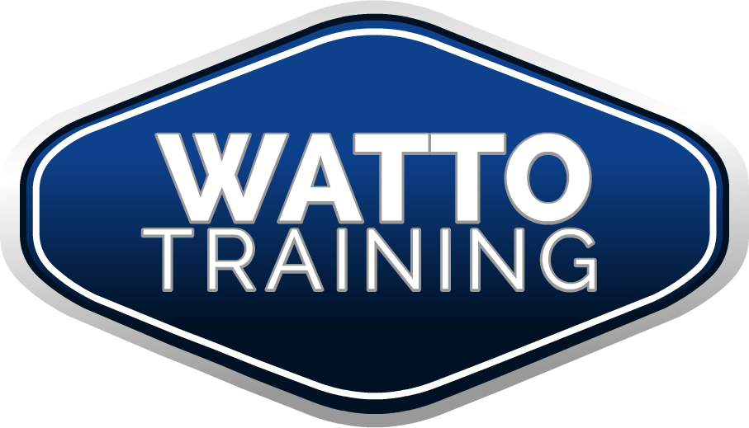

What is a Training Plan?

A Training Plan is a document that is used to plan learning, usually over an extended period of time.

Training is teaching, or developing in oneself or others, any skills and knowledge that relate to specific useful competencies. Training has specific goals for improving one’s capability, capacity, productivity and performance.

So why do we need a learning program?

A learning program provides the trainer/assessor with information about the competencies being delivered, a profile of the learners and their needs, and suggestions for the assessment strategy. From this, the trainer/assessor can develop the delivery plan and the session plan.

The training plan must specify the following:
- the competencies to be obtained
- the time-frame for achieving the competencies
- the training to be undertaken
- the delivery modes to be employed
- the details (when, how and how much) of the time allocated outside routine work duties is for off-the-job training
- who is responsible for the delivery and/or assessment of each competency
- assessment details and arrangements
- a record of any recognised prior learning (RPL) for qualifications and cross-credit hours granted prior to commencing the apprenticeship or traineeship. RPL involves the assessment of any existing relevant skills and/or qualifications. This crediting process can reduce the length of the off-the-job training or the duration of the overall apprenticeship or traineeship.
- the name of the qualification to be issued
- any other specific requirements to be met in accordance with the particular training contract in question

